

College of Science & Mathematics Student Success Center
Biology Major Course Recommendations

These recommendations will help you build your WISER course schedule “shopping cart” based the sample schedules below.

Your math placement result determines which sample schedule to select.

If you are placed into MATH115, take... BIOL111 - General Biology I; 4 Credits MATH115 - College Algebra; 3 Credits
ENGL101 - Composition I; 3 Credits
BIOL 187S - Gateway Seminar; 2 Credits₍₁₎
General Education Distribution - 3 Credits

Total Credits: 15
If you are placed into MATH130, take...
BIOL111 - General Biology I; 4 Credits
MATH130 - Pre-Calc ; 3 Credits
CHEM115 & CHEM117 - Chemistry I ; 5 Credits
ENGL101 - Composition I; 3 Credits
BIOL 187S - Gateway Seminar; 2 Credits₍₁₎

Total Credits: 17

If you are placed into MATH140, take...
BIOL111 - General Biology I; 4 Credits
MATH140 - Calculus I; 4 Credits
CHEM115 & CHEM117 - Chemistry I ; 5 Credits
ENGL101 - Composition I; 3Credits
BIOL 187S - Gateway Seminar; 2 Credits₍₁₎

Total Credits: 18 (requires a credit overload)

Important Considerations:
⁽¹⁾The First Year Seminar Requirement can be satisfied by taking either a:
First Year Seminar G-100 level (4-credits), or
Year-long sequence of Gateway Seminars (2-credits each) - Gateway seminars fill up quickly!
Enrollment into CHEM 115 and CHEM 117 requires placement into Math 130. (ALEKS: 59, SAT: 590, ACT: 25)
If you have earned AP credit or have dual enrollment credit being transferred, speak to an advisor.

For Future Academic Planning:
Some classes have grade requirements that must be met in order to move on to the next level of a class. These are called prerequisites.
- MATH115: Earn a B or better to move on to Math 130
- MATH130: Earn a B or better to move on to Math 140
- MATH140: Earn a C- or better to move on to Math 141
- CHEM115: Earn a C- or better to move on to CHEM116
- CHEM116: Earn a C- or better to move on to CHEM251

College of Science & Mathematics Student Success Center Biochem/Chemistry Major Course Recommendations

These recommendations will help you build your WISER course schedule “shopping cart” based the sample schedules below.

Your math placement result determines which sample schedule to select.

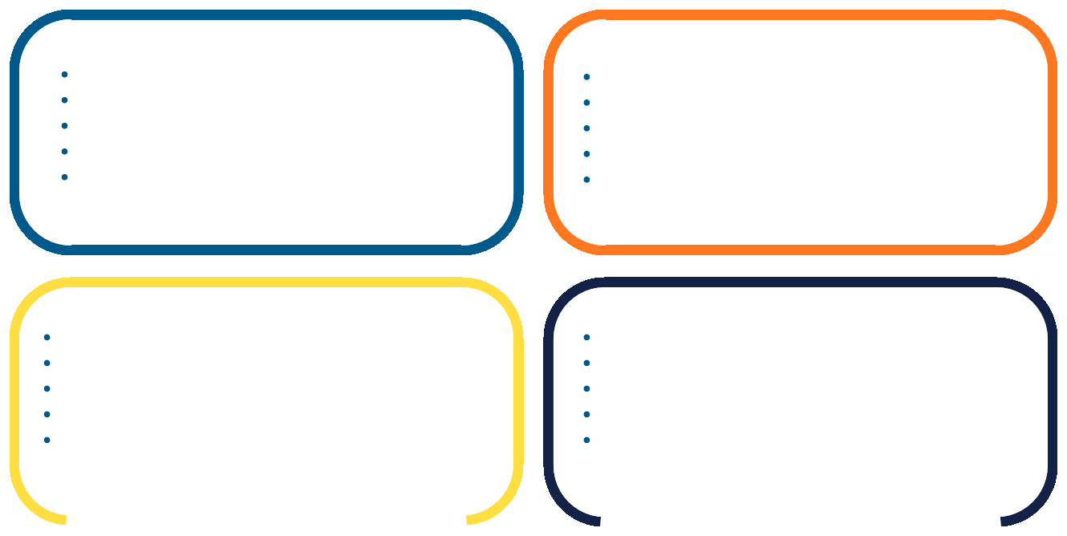
If you are placed into MATH115, take... BIOL111 - General Biology I; 4 Credits MATH115 - College Algebra; 3 Credits ENGL101 - Composition I; 3 Credits
General Education Distribution - 3 Credits
CHEM 187S - Gateway Seminar; 2 Credits₍₁₎

Total Credits: 15
If you are placed into MATH130, take...
BIOL111 - General Biology I; 4 Credits
MATH130 - Pre-Calc ; 3 Credits
CHEM115 & CHEM117 - Chemistry I ; 5 Credits
ENGL101 - Composition I; 3 Credits
CHEM 187S - Gateway Seminar; 2 Credits₍₁₎

Total Credits: 17

If you are placed into MATH140, take...
BIOL111 - General Biology I; 4 Credits
MATH140 - Calculus I; 4 Credits
CHEM115 & CHEM117 - Chemistry I ; 5 Credits
ENGL101 - Composition I; 3 Credits
CHEM 187S - Gateway Seminar; 2 Credits₍₁₎

Total Credits: 18 (requires a credit overload)
If you received credit for MATH140... BIOL111 - General Biology I; 4 Credits MATH141 - Calculus II; 4 Credits
CHEM115 & CHEM117 - Chemistry I ; 5 Credits
ENGL101 - Composition I; 3 Credits
CHEM 187S - Gateway Seminar; 2 Credits₍₁₎

Total Credits: 18 (requires a credit overload)

Important Considerations:
⁽¹⁾The First Year Seminar Requirement can be satisfied by taking either a:
- First Year Seminar G-100 level (4-credits), or
- Year-long sequence of Gateway Seminars (2-credits each) - Gateway seminars fill up quickly!
Enrollment into CHEM 115 and CHEM 117 requires placement into Math 130. (ALEKS: 59, SAT: 590, ACT: 25)
If you have earned AP credit or have dual enrollment credit being transferred, speak to an advisor.

For Future Academic Planning:
Some classes have grade requirements that must be met in order to move on to the next level of a class. These are called prerequisites.
- MATH115: Earn a B or better to move on to Math 130
- MATH130: Earn a B or better to move on to Math 140
- MATH140: Earn a C- or better to move on to Math 141
- CHEM115:Earn a C- or better to move on to CHEM116
- CHEM116: Earn a C- or better to move on to CHEM251
- CHEM251 Earn a C- or better to move on to CHEM252

