Transact – Reporting Job Aid
- Log in to Transact using single sign-on URL:
  - Https://webauth.cashnet.com/incadmin/Shibboleth.sso/Login?entityID=https%3A%2F%2Fvm-shibboleth.umb.edu%2Fidp%2Fshibboleth

- Click on Reports
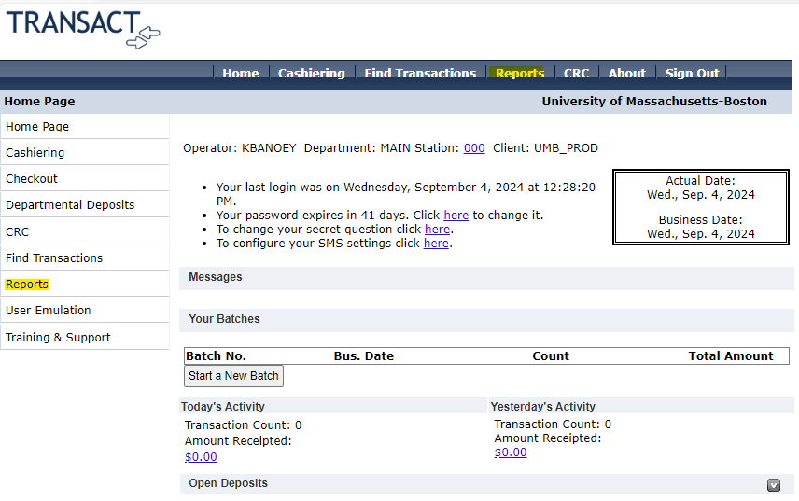

- Select the report created for your department under “Paid Items Report.” We will select the SEAS report for this example.
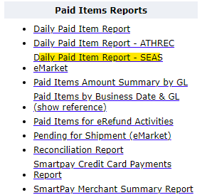
- Select the date range desired for the report and hit refresh. This will regenerate the report for the selected date period.
- For additional report customization, click on “Customize.”
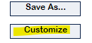
Item Types:
To select a specific item code for your department, select Item Code in the customize page
and click on the specific item code needed.
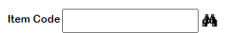
Format:
In the Format section, the reference/detail fields you need to appear on your report can be selected. Click on the field on the left box and move it over to the right box with the arrow button. Once customization is done, click on ok.
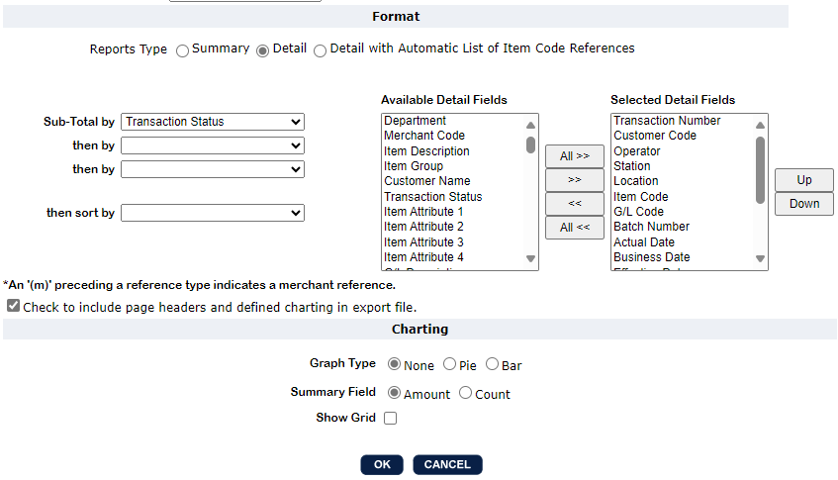
- To export the report, click on the “Select Format” drop down for the desired format and slick on “Export to File.” For reconciliation purposes, csv may be the most useful format.
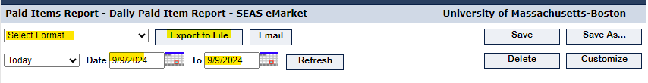
- Open file once it has been downloaded.

