**Transact – Reporting Job Aid**

1. Log in to PS Finance and select General Ledger & Budget
2. Click on Review Ledger Information under Review Financial Information

1. Click on Add a New Value tab and add an inquiry name and click on Add
2. Fill in the data as shown below and ensure to enter the correct account, department, fund, and program for your department and hit Save once all set.

1. Once Added, go back to Find an Existing Value, Click on Search and select the inquiry created.
2. Once the inquiry has been selected, click on the search button



1. Select the fiscal year accounting period that needs to be reconciled and click on Activity.

1. Click on the highlighted icon to download the data into excel



1. Disregard or delete the other non-Transact entries for reconciliation purposes.
2. Take a total of items to be reconciled, for this example, the total is $150.



1. Run a Transact report to generate monthly activity for the department.
   1. For assistance to produce Transact report, please see Transact Report Generation Job Aid.
2. Compare and contract to ensure totals match with PS Finance report, which is does in this example.

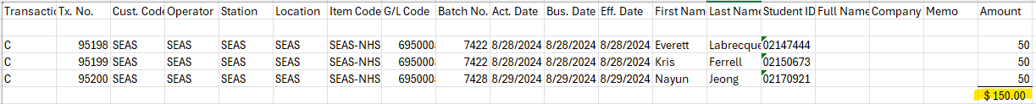

1. Copy and paste data for both reports into one excel spreadsheet with two separate tabs containing both (see below example) and save file.

