The College of Liberal Arts
Annual Report
June 2007

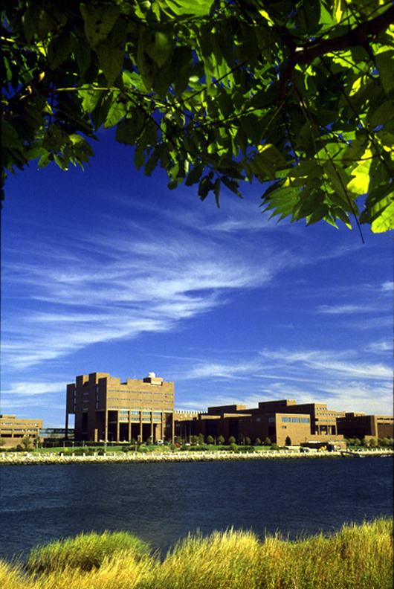

Accomplishments

FY 07 has been a very successful year for the College of Liberal Arts. We have continued to play a leading role in the University’s research mission, and have accommodated increasing numbers of undergraduate students: including our own majors both declared and undeclared, and students from the other units.

Research and graduate education

CLA faculty authored or edited and had published 31 books, monographs, and special issues of journals, 145 articles and review essays, 32 short articles, 31 poems and short stories, a novella, and one music CD. Three other books were published in translation. Three music compositions and one play were performed. . Faculty directed, acted in and did technical work for 21 plays, gave 21 readings and gave 31 musical performances.
In FY 06 the College generated $2M in external funding. In FY 07 CLA faculty received a number of major grants including:
- Alice Carter, Autism Speaks, A Multi-Site Clinical Randomized Trial of the Hanen More than Words Intervention, $1,200,000
- John Steinberg, National Science Foundation, Chiefdom to Manor: Comparative Excavations at Primary and Secondary Viking Age Farmsteads in Skagafjordur, Iceland, $238,629
- Donaldo Macedo, Cambridge Public Schools (prime sponsor – US Department of Education), Peng Yo (friends) Project: Mandrarin for Real Life Purposes, $60,000
- Rajini Srikanth, Ford Foundation, Engaging Islam: Feminisms, Religiosities, Self-Determinations, $100,000
- Lizabeth Roemer, National Institutes of Health, A Randomized Controlled Trial of Acceptance-Based Behavior Therapy for Generalized Anxiety Disorder, $2,344,077
The hiring of a dedicated CLA staff member in ORSP as of January 2, 2007 has already improved the management of sponsored funding in the College. Jennifer Giglio has been successful in assisting faculty and has thus far helped approximately 40 faculty with sponsored projects or applications.
The newly approved MFA in Creative Writing has admitted a stellar first class for the fall of 2007, and we have successfully recruited an outstanding Korean-American poet, Suji Kwok Kim, who will join the faculty in January 2008.
The Research Center for Urban Cultural History (RCUCH) had a very successful year, sponsoring its first Betty and Matt Flaherty Lecture, featuring Nancy Seasholes, speaking on “Gaining Ground in South Boston.” The spring semester opened with a lecture targeted at undergraduates. Stephen Puleo talked about research for his book, Dark Tide: The great Boston Molasses Flood of 1919 and gave the students tips on archival research. Many other activities were held throughout the year. Center director Professor Elizabeth Fay submitted a $250,000 NEH/ILS grant proposal in collaboration with the Massachusetts State Archives, entitled “The Massachusetts Hours of Labor Debates Project.”
The Psychology Department advanced its plan to create a research cluster in developmental and brain science, by hiring an outstanding senior researcher, Professor Edward Tronick of Children’s Hospital. We expect his presence to increase our collaborations with Children’s Hospital, and we expect him to work with both ICI and the Venture Development Center. While our first junior hire under the new plan, Javid Sadr’s first semester was marred by serious health problems, we expect him to return in the fall. We are currently working on a second junior hire who would join us in September 08 and hope to recruit a third this coming fall. At this point we are close enough to having sufficient strength to propose the second PhD in Psychology, and preliminary planning for that degree has just begun. This project, which will involve both internal and external collaborations, will build on the Psychology Department’s considerable strengths, and will round out its graduate programs. This is a project which has had support from the Provost’s Office, and which will require additional support once the program is a reality. Budgets will be developed during the planning process.
The PhD in Clinical Psychology went through its reaccreditation process this past year, and we expect it to pass with flying colors. We have already received a very positive site visit report. The program continues to maintain the highest standards including the most selective admissions statistics by far in the University, and to serve the urban mission by graduating practitioners prepared to work with diverse populations. This spring the program graduated a total of fourteen PhDs, more than the number of PhDs produced by any of the other colleges this year.
In collaboration with Associate Vice Chancellor for Research, Richard Antonak, we have developed a plan to increase research productivity in the already successful Fiske Center for Historical Archeology. By adding new equipment, and funding additional support personnel, the Center will be able to expand its activities.
The History Department continues its search for a faculty member to revive the Archives track in its masters program, and we hope to have this project on its feet by the end of the coming year.
As of this writing, the College has pending requests for an additional ten graduate stipends. These stipends will help us better support our graduate programs.
The internal funds that support research and scholarly travel in the College of Liberal Arts supported a total of 42 faculty who were giving papers at scholarly meetings and provided research grants to 13 faculty members. I continue to refine the guidelines for these funds to meet faculty needs. The largest concern here is budgetary. Because the College continues to be severely under funded, the future of these funds is in doubt each year.
With the changes in Graduate Studies, in conjunction with the increasing number of personnel cases, PMYRs and AQUADs that the College faces, we were successful in appointing a second associate dean, effective September 1, 2007. That position will be filled by Pamela Annas of the English Department, an experienced faculty member and Graduate Program Director. She will serve as the point person for graduate issues in the dean’s office.

Undergraduate student teaching and learning

The College of Liberal arts remains the largest generator of CTF profit net of costs in the University and as student enrollments increase, our role in educating both our own students and those from other units, will continue to grow. Rebuilding the faculty is key to assuring high quality student teaching and learning. CLA faculty serve not only our own students but those in other units by teaching the preponderant majority of General Education courses, Honors courses, and running the Center for the Improvement of Teaching. We rely too heavily on non track faculty, and the majority of the tenured faculty is over 55. Here is a brief overview of our situation:
- In Fall 06, the College of Liberal Arts taught 54.7% of its undergraduate courses with non tenure stream faculty. This compares to 51.3% in Fall 05.
- In Fall 05, 42% of the tenured and tenure track faculty were 55 or older, and of these 23% were 60 or older.
- Between Fall 96 and Fall 06 the TTT share of faculty in CLA has decreased from 75% to 62%.
- For Fall 06, our ratio of FTE TTT faculty to majors is 1:28 increasing from 1:26.5 in Fall 05.
- For Fall 06, our ratio of FTE TTT faculty to IFTE students is 1: 25 increasing from 1:23 in Fall 05.
Research shows that at institutions like ours, graduation rates drop in proportion to the drop in the percentage of instruction from TTT faculty. Insufficient TTT faculty mean less mentoring of our students and fewer research opportunities for them. Our goal is to provide 65 to 70% of all instruction by tenured and tenure-track faculty. To achieve this goal we must replace all retirements or resignations and add new faculty lines.
During the 2006-2007, the College of Liberal Arts successfully hired 8 junior faculty and 1 senior faculty. Planning for the FY08 line requests, with an FY 09 impact is now underway. We need to hire at a higher rate if we are to raise the percentage of tenure stream faculty. In Fall 2000, CLA’s FTE faculty was 70% TTT faculty. In Fall 2006, it was 57% TTT faculty.
The first-year seminar program is one of the most important ways in which we introduce new students to the University, usually in their all-important first year in college which is strongly predictive of future success. One of my goals has been to increase the number of sections of the first year seminars taught by TTT faculty. In Fall 04 15% of the first year seminars were taught by TTT faculty. In the first year of my program that number increased to 30%, and in fall 06 the proportion will rose to 42%. The increase in enrollments is impacting our success in this effort however, and in fall 07 the percentage will fall back to about 35%. In the context of the enrollment goal of 15,000 students by 2010 (15X10), this effort cannot succeed without a strong program of hiring tenure stream faculty.
The College developed and approved a new major in Asian Studies, an interdisciplinary field that allows students to learn about the economics, history, culture, politics and languages of an increasingly important part of the world. That proposal is now being revised prior to being submitted to the Board of Trustees for approval. At the same time it suspended the major in German Studies and the program in the Study of Religion. The former was not viable because of very limited student demand, and the latter because the costs of providing adequate faculty resources was too great to be borne at this time.
Last year, we initiated a process of updating the basic standards for the structure of majors and minors. This project has two goals. On the one hand, we want to assure good academic standards, making certain for example that all majors include a minimum number of advanced courses, and on the other we want to make the curriculum and its possibilities more transparent for students, eliminating the confusing and overlapping categories of minors, programs of study and certificates. That revision has just been approved by the committee on Majors, Honors and Special Programs and will come before the CLA Senate in the fall.
This year we revised our web pages, and created a program booklet for student recruitment that has become the model for the other undergraduate units.
We have continued to carefully monitor course enrollments with the result that in fall 06, at the end of add drop, our undergraduate course sections were 91.2% full, with an average section size of 28.9 students. Our graduate courses were filled to 82.7% of capacity with an average class size of 12.9 students. In Spring 07 overall undergraduate courses were filled to 90.7% capacity. The average undergraduate class size was 28.1 students. Graduate courses were filled to 77.6% capacity. The average graduate class size was 11.6 students.
We continue to have major concerns about our undeclared students. As I have noted in my annual reports, and in my most recent budget request, the College needs to have professional advisors to work on a consistent basis with these students, who at the moment have no structural relationship to the college in which they are enrolled. As a group undeclared students are at a higher risk of dropping out, and while the Advising Center provides valuable services, it is not a substitute for College-based advising.

Financial Management

My budget requests for FY 07 were as follows:
- $159,000 to increase departmental operations budgets
- $65,000 to stabilize funding for faculty research and faculty travel
- $20,000 for enrollment, admissions and retention initiatives
- $85,000 in extraordinary start-up
- $210,00 in new staffing dollars
The College received a total of $80,000 in incremental funding. Beyond this the Provost funded the full amount promised to the new Master’s in Creative Writing. The $80,000 was distributed as follows:
- $21,000 to partially fund a staff position already created and representing a prior commitment.
- $26,000 to support faculty research and travel
- $10,000 for development and admissions initiatives
- $23,000 to departments to increase operational budgets.
The College’s budget continues to be a challenge, as we have, by considerable margins, the lowest levels of staffing and the lowest amount of CTF dollars per FTE faculty or per IFTE student taught. With the increasing demands for start-up funds, if the College does not receive a significant base increase in FY 08, by FY 09 it will have to curtail research and travel support as well as limiting other activities.

Goals for FY 08

- Overall
  - Craft a new College strategic plan within in the framework of the University Strategic Plan.
  - Obtain sufficient faculty lines to continue increase the proportion of tenure stream faculty.
  - Obtain adequate office and laboratory space for the College’s programs.
  - Improve responsiveness to faculty/departments and to graduate programs with the presence of second associate dean.
- Research and graduate education
  - Draft plan for second PhD in Psychology.
  - Obtain a minimum of 10 additional graduate fellowships.
  - Obtain sufficient CTF allocation to base fund the College’s research and travel funds.
  - Increase sponsored funding.
  - Fund 10% of DRA’s salary.
  - Obtain sufficient CTF allocation to continue contributing to start up costs.
- Undergraduate Student Teaching and Learning
  - Revision of standards for majors and minors is completed.
  - Obtain funding for College based professional advisors, especially for our undeclared students.
- Financial Management
  - Improve staffing situation through addition of two business managers, each of whom would serve a cluster of six to seven departments that have only one staff member at present.
  - Increase operating dollars to departments.

Based on 05-06 AFRs. The reporting lags one year behind.
Reporting lags a year behind.
Referred to hereinafter as TTT faculty.
I provide Fall 05 date because OIRP has not run this data for Fall 06.
For a summary of this research see the report of the Academics Sub-Committee, Appendix 3.
Because the institution now keeps the numbers only including CCDE faculty, I compare the first year for which we have the figures kept in this way, Fall 2000 to Fall 2006. The effects of the retirement programs and the additional students without sufficient TTT hires are apparent.
Assuming we do not add any sections over the summer for increased enrollment.
In 2006-2007 there were 48 sections of G100 courses, of which six were offered by Academic Support and all the remaining by CLA. None of the other undergraduate units contributed any courses.

